Making Population Pyramids for Districts (and Winnipeg CAs/NCs)

Step 1: open the ‘district population pyramids’ Excel file and click on the ‘orig. data’ sheet

Step 2: select and copy the 19 rows of data in columns C to F for the desired district

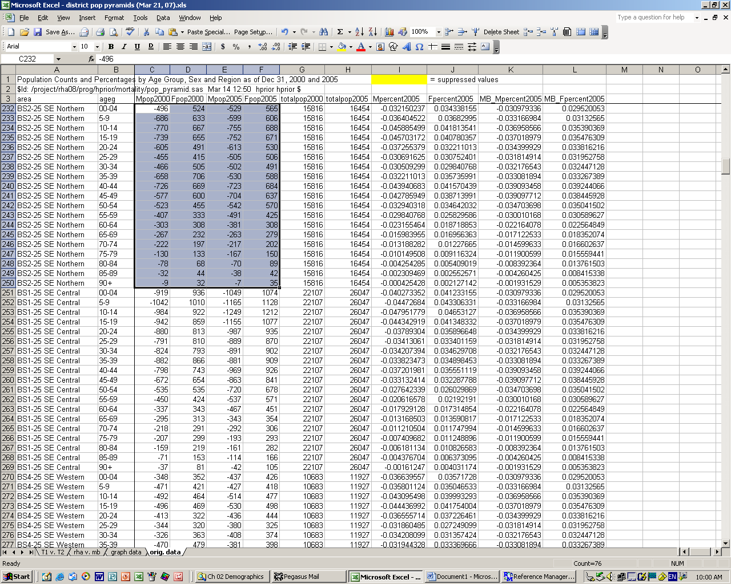

Step 3: paste the above selection onto the ‘graph data’ sheet in cells C5 to F23

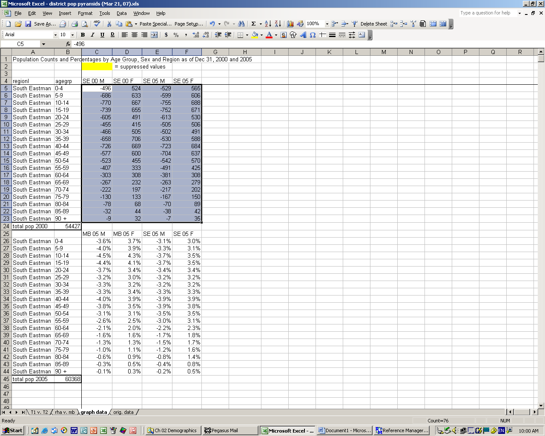

Step 4: go back to the ‘orig. data’ sheet and copy the 19 rows of data in columns I to L for the
desired district

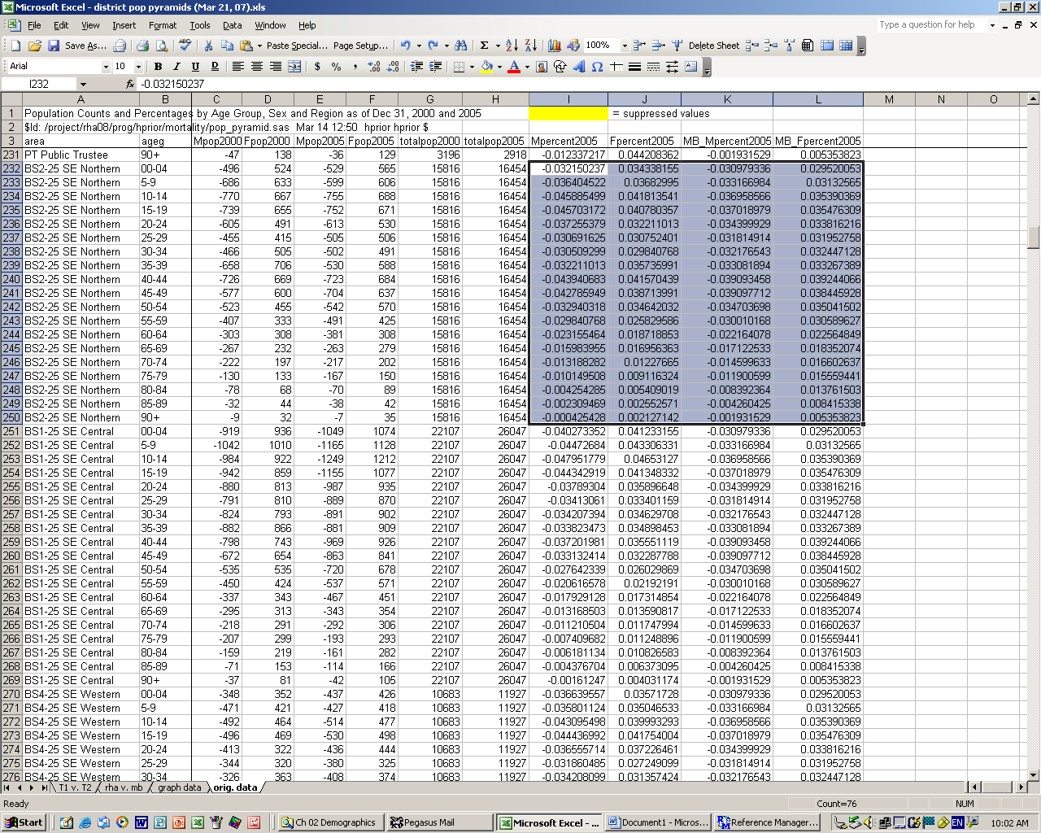

Step 5: paste the above selection onto the ‘graph data’ sheet in cells C26 to F44

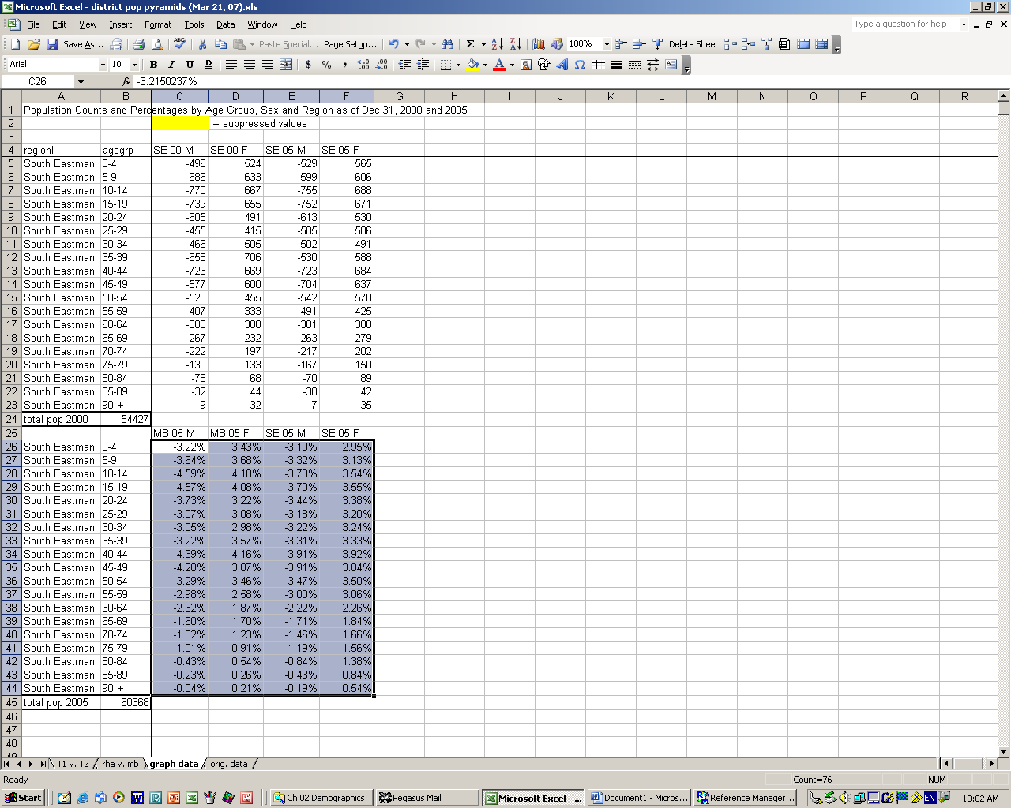

Step 6: copy the population value for each time period from the ‘orig. data’ sheet (one of the
cells in column G for time period 1 and one of the cells in column H – they are all the
same, so you need to copy only one) to cell B24 and B45 respectively on the ‘graph
data’ sheet

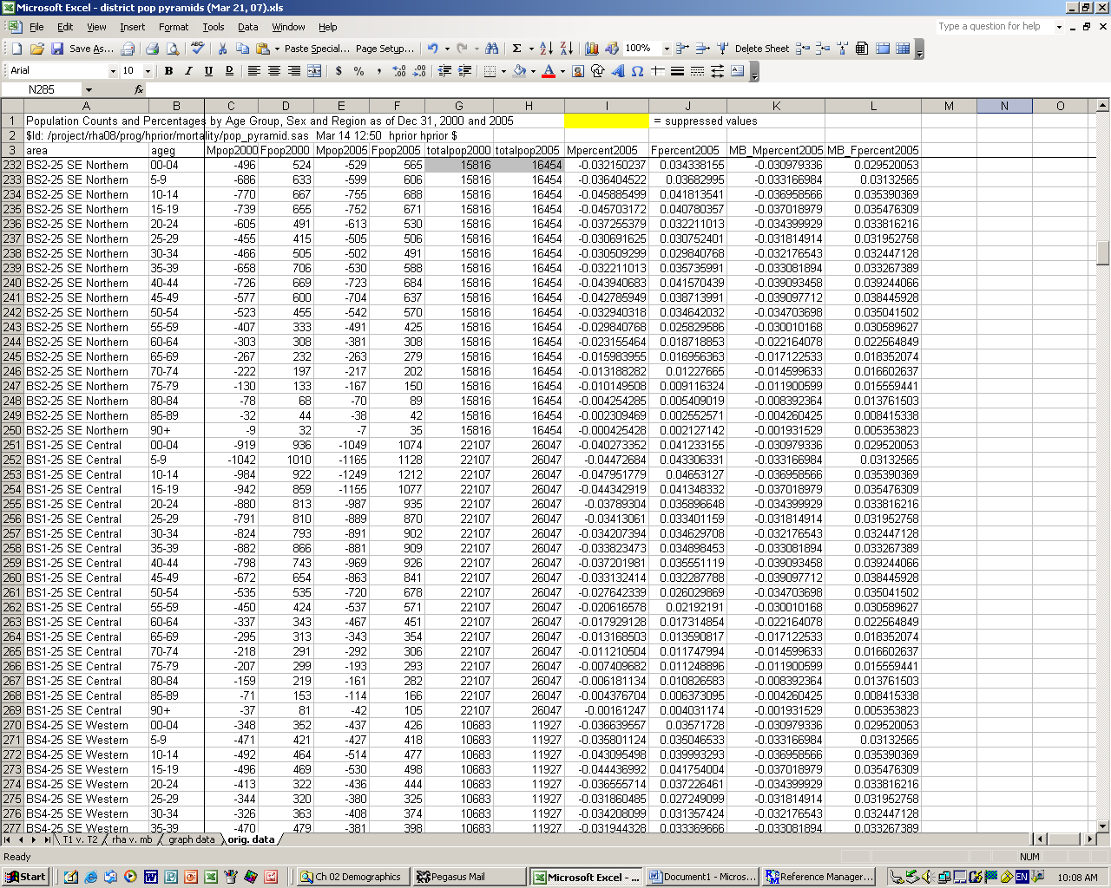

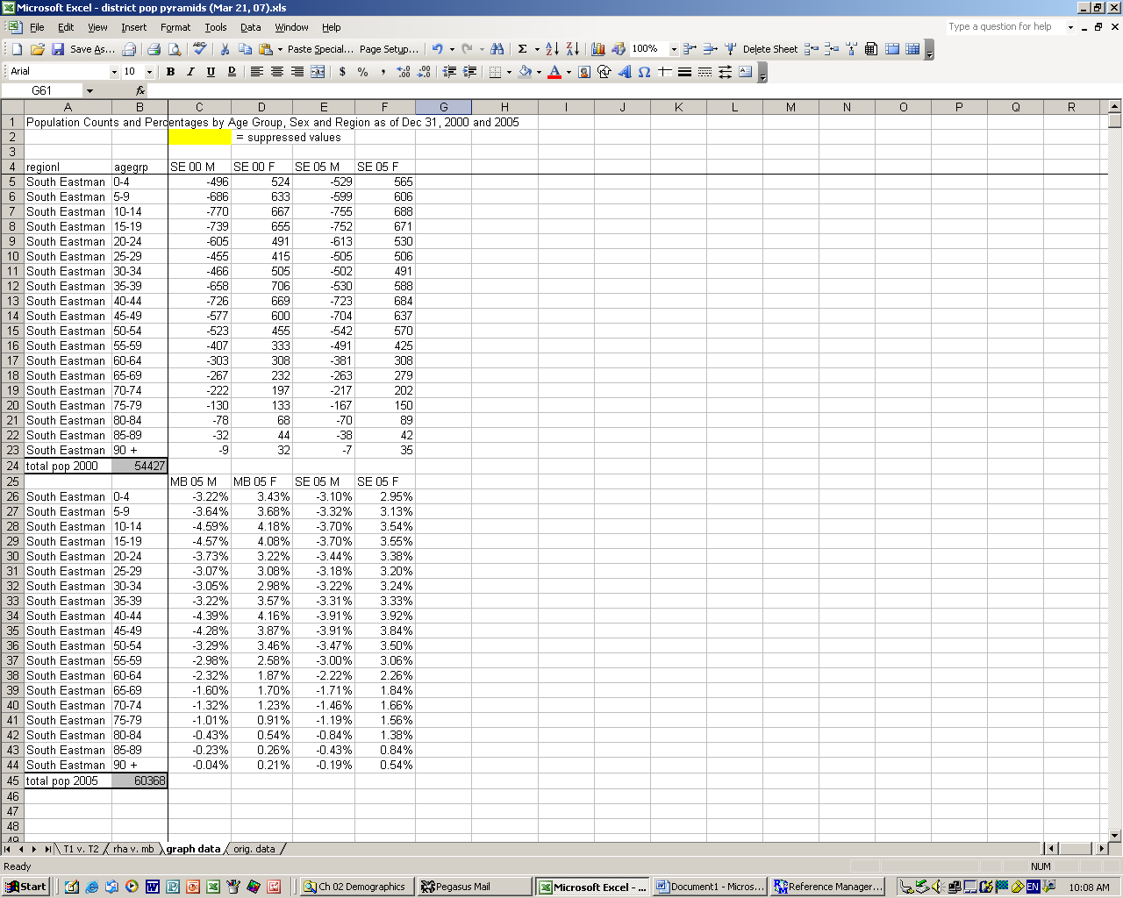

Step 7: also change the population values on the corresponding graphs (go the ‘T1 v. T2’ and
the ‘rha v. mb’ tabs respectively)

*note: the population value for Manitoba on the ‘rha v. mb’ graph is correct and does not
need to be changed

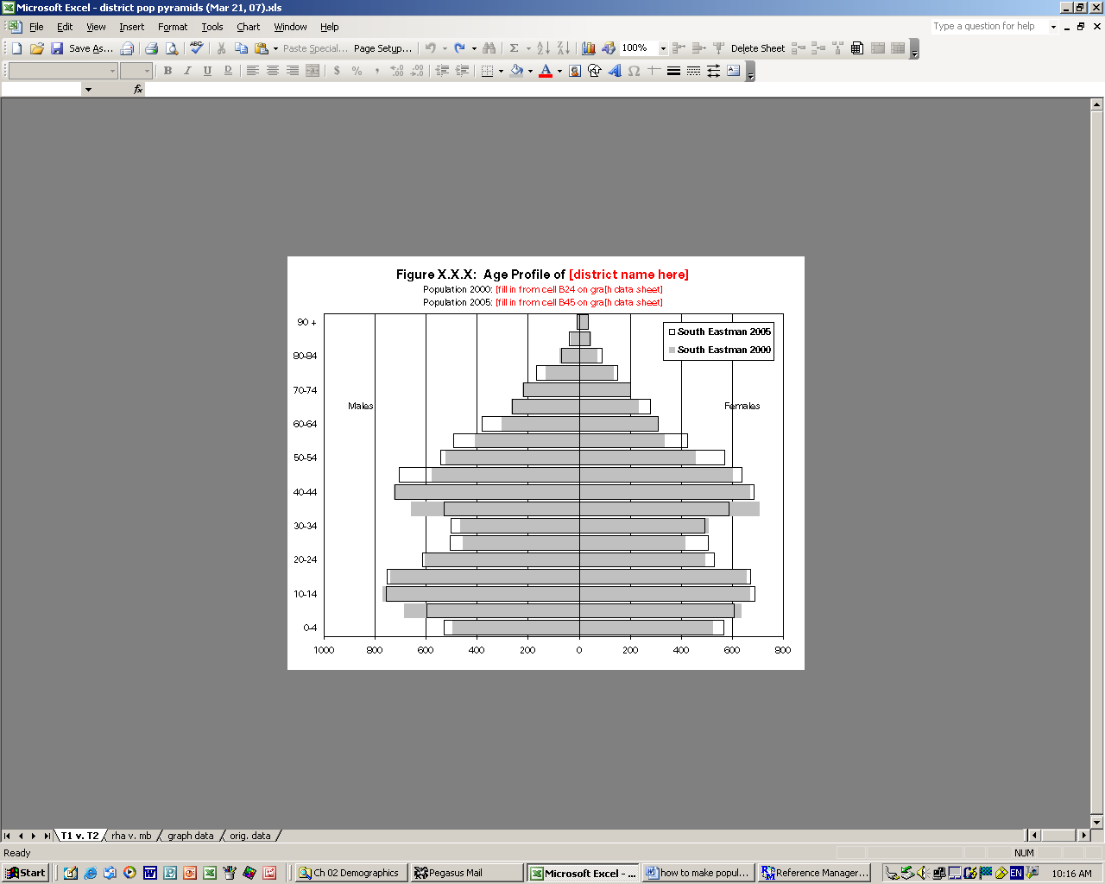

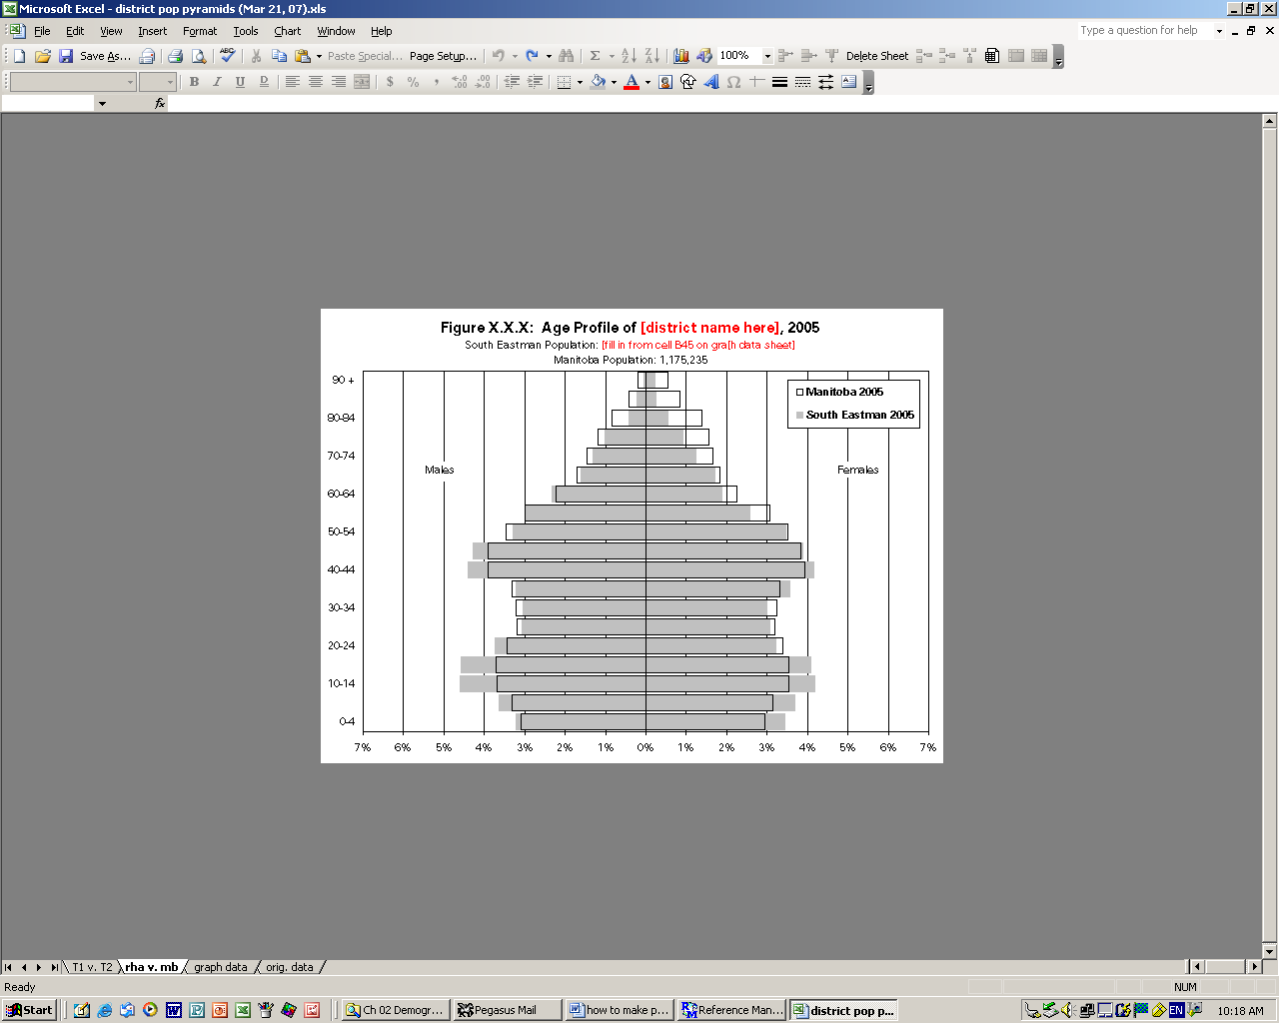

Step 8: change the cells in column A on the ‘graph data’ sheet to the correct district name

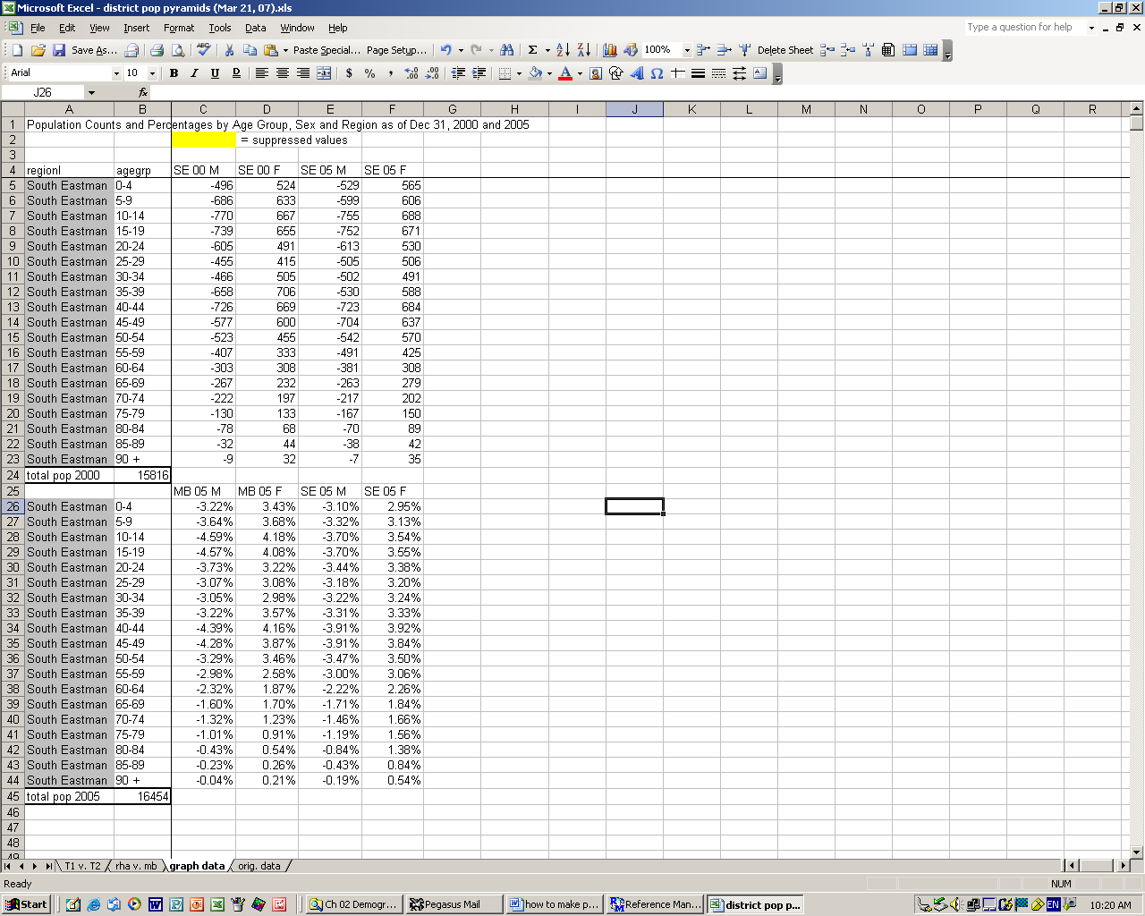

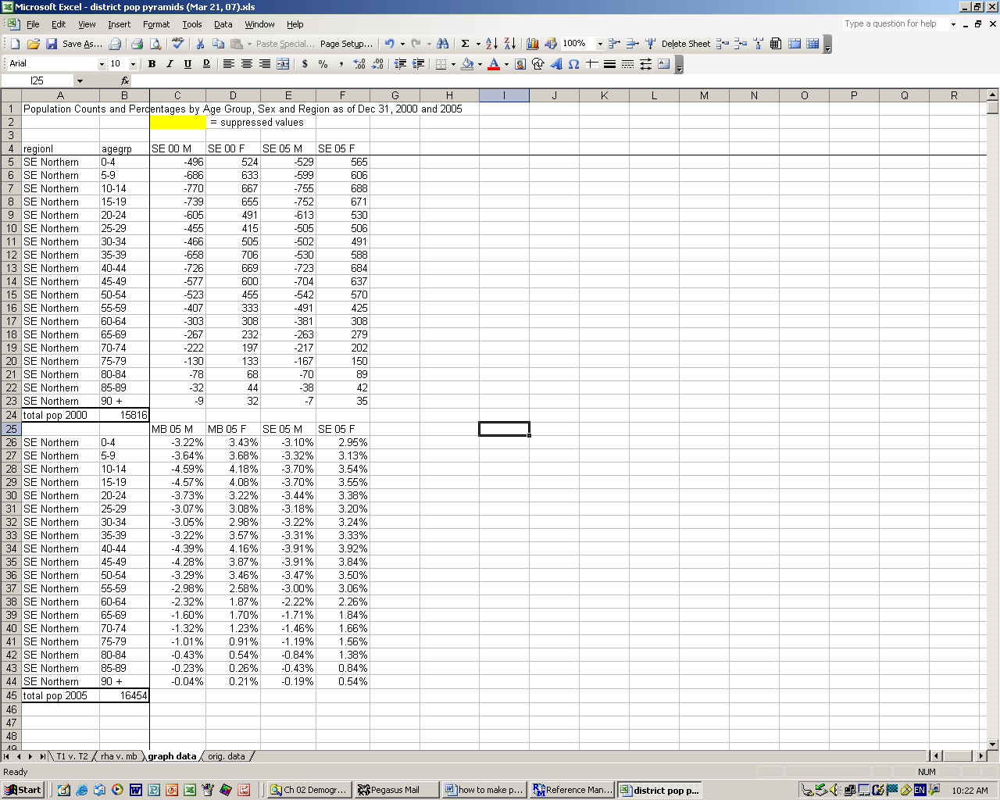

Step 9: change the names on the graphs to the correct district name

Step 10: change the legends on each graph by right clicking on a data series on the
graph (any will work) and selecting ‘source data’

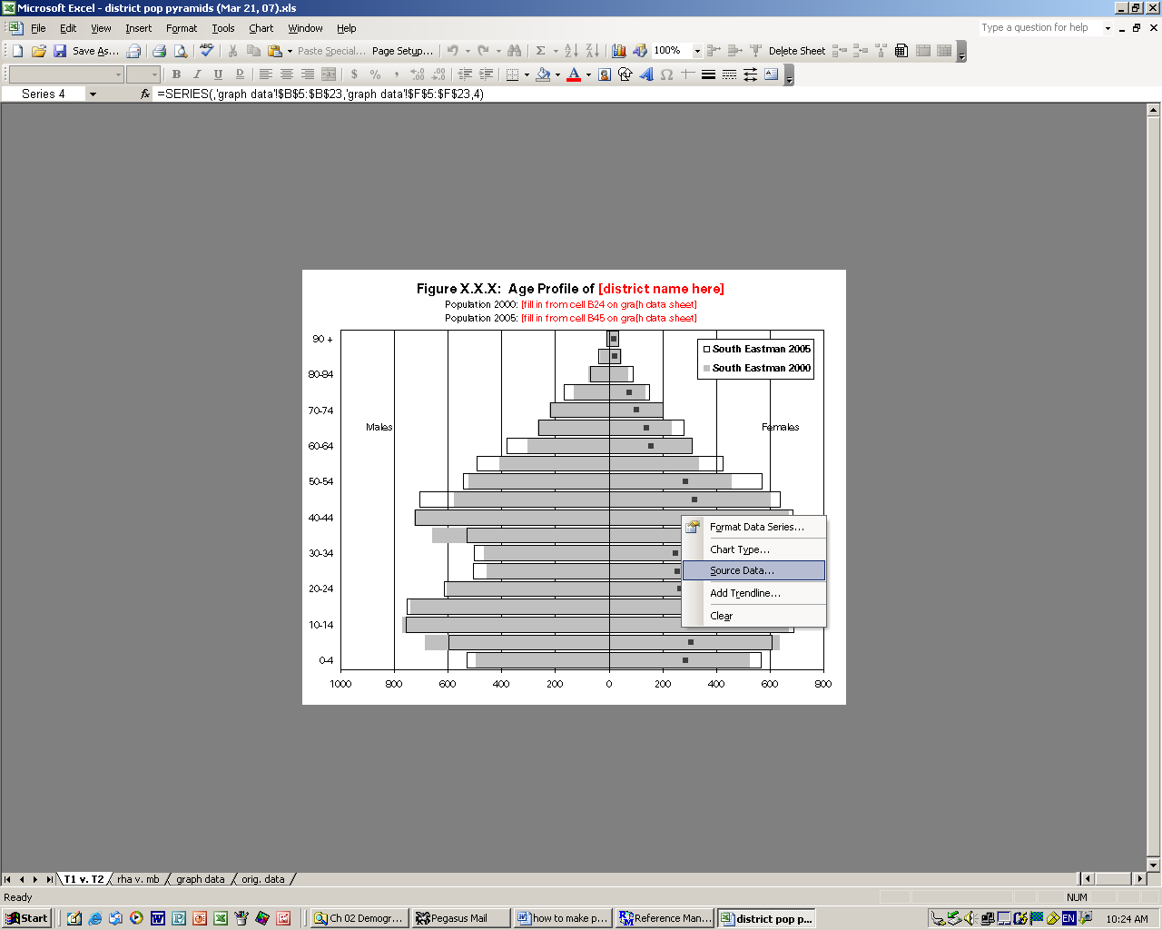

Step 11: on the ‘T1 v. T2’ graph, click on the ‘series’ tab, select the first series in the series box
and change the name to the correct district name

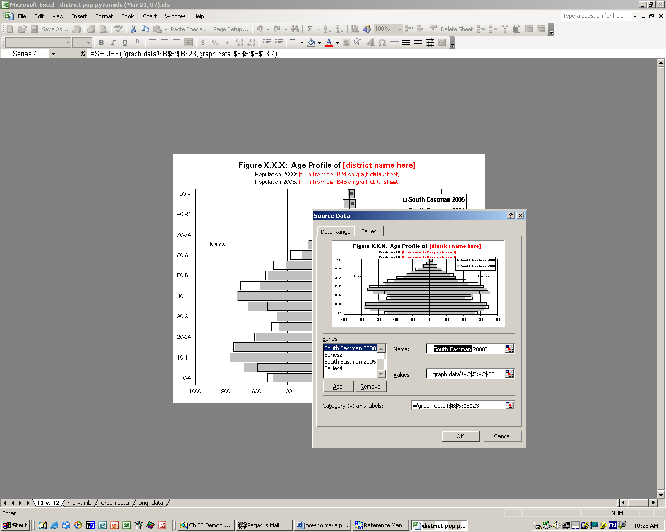

Step 12: while still in this dialogue box, select the third series, change the name to the correct
district name; click ‘ok’ (note: need to change both – comparing same district over time)

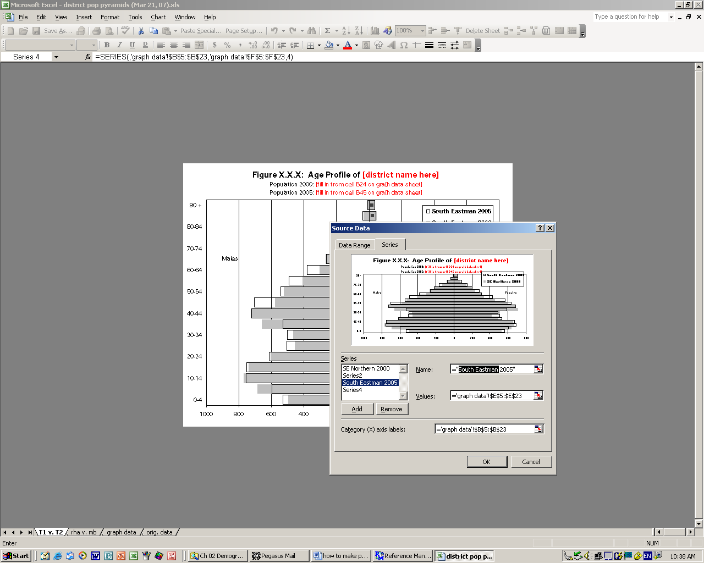

Step 13: repeat steps 11 & 12 for the ‘rha v. mb’ graph, BUT only change the first series name –
Manitoba (the third series) is correct for this graph (it is the comparison group here)

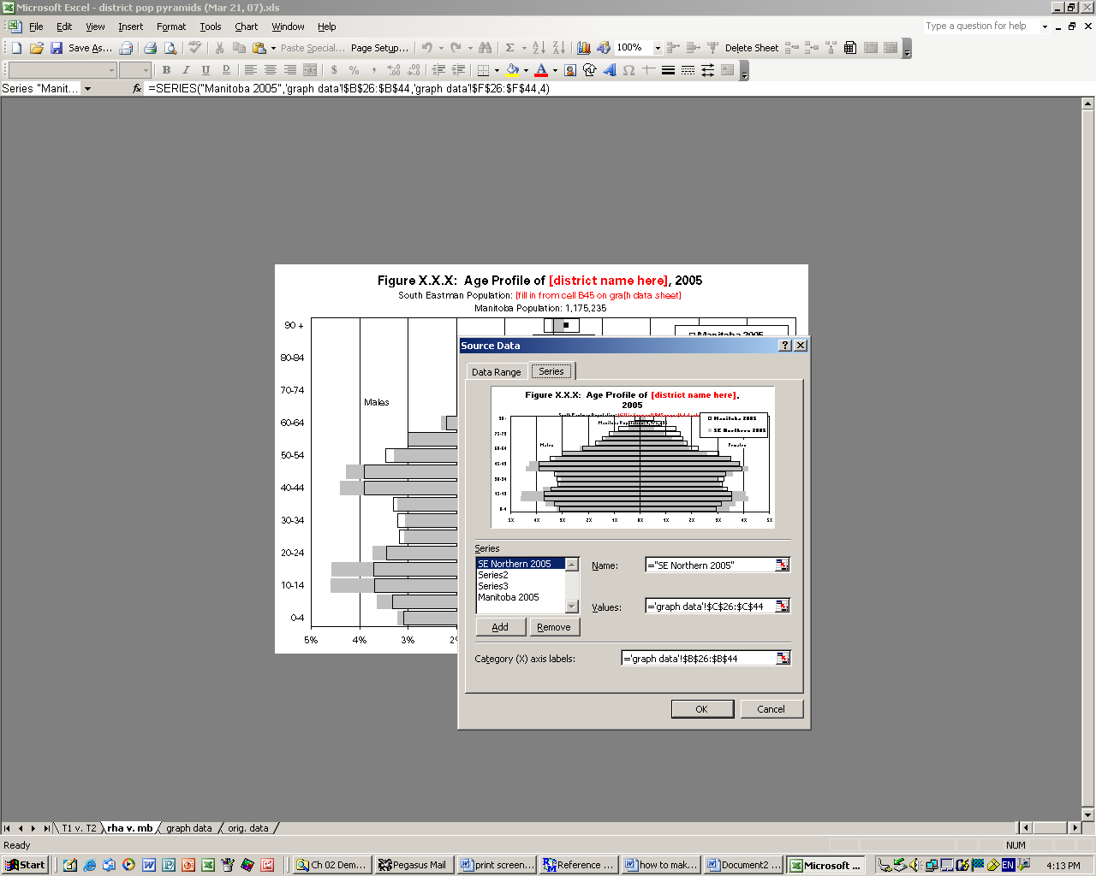

Step 14: change the graph scales (if necessary) by double left clicking on the horizontal graph
axis, selecting ‘scale’ tab and changing values in ‘minimum’ and ‘maximum’ boxes (in
example below, the males’ scale goes to 1000, but the females’ only goes to
800, so change to match)

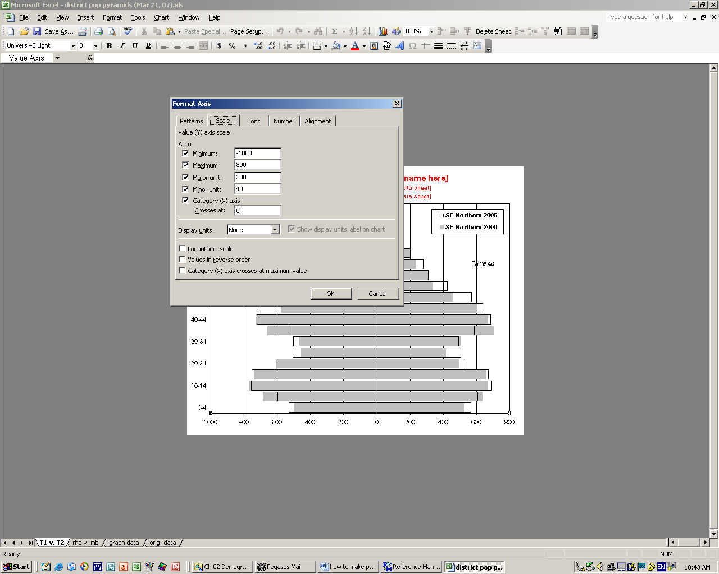
**If you are using Windows XP, see below for minor differences in steps 10-14:

Step 10: change the legends on each graph by right clicking on a data series on the
graph (any will work) and choosing ‘select data’

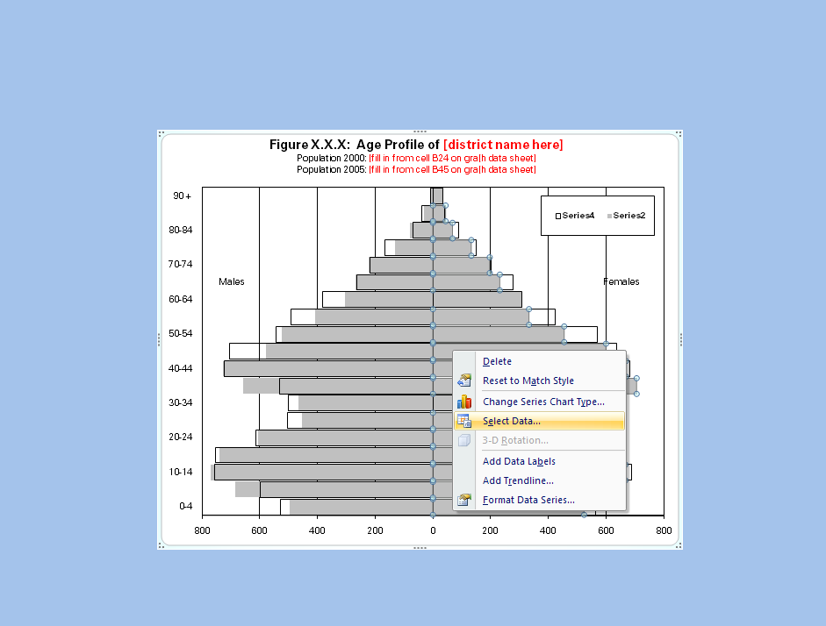

Step 11: on the ‘T1 v. T2’ graph, click on the ‘edit’, select the first series in the series box
and change the name to the correct district name

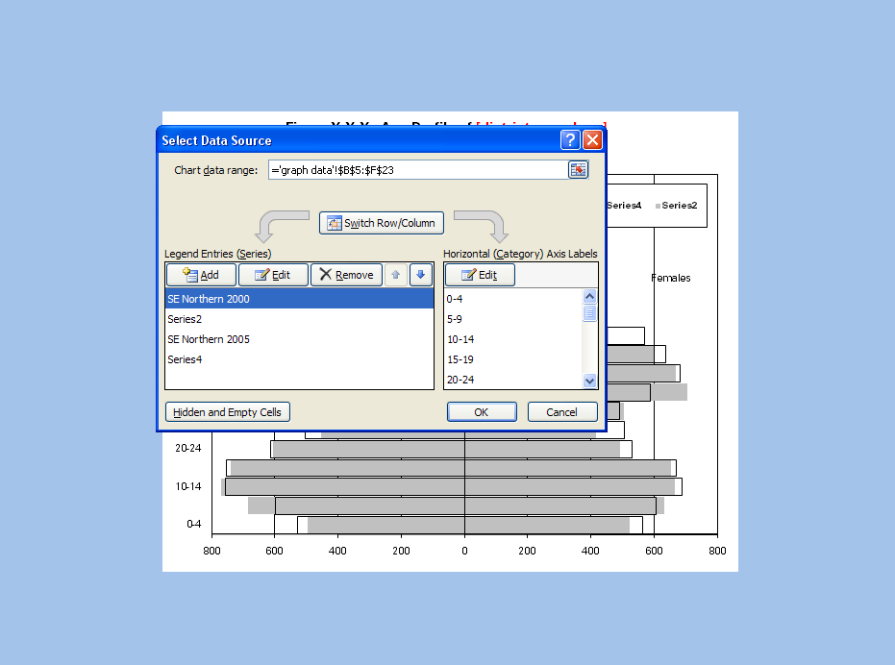
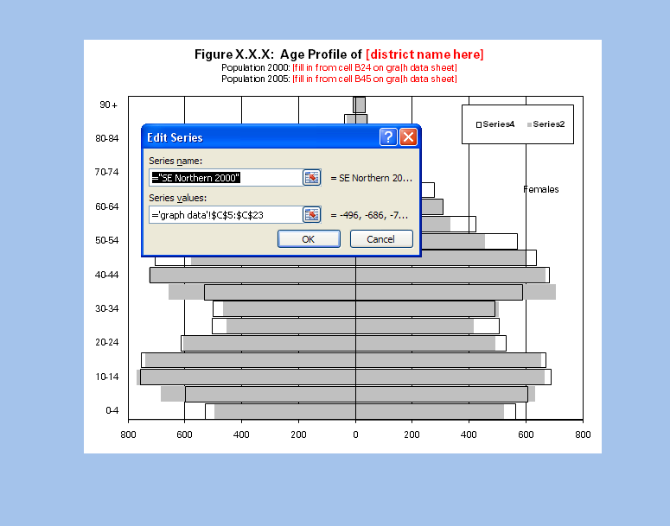

Step 12: while still in this dialogue box, select the third series, change the name to the correct
district name; click ‘ok’ (note: need to change both – comparing same district over time)

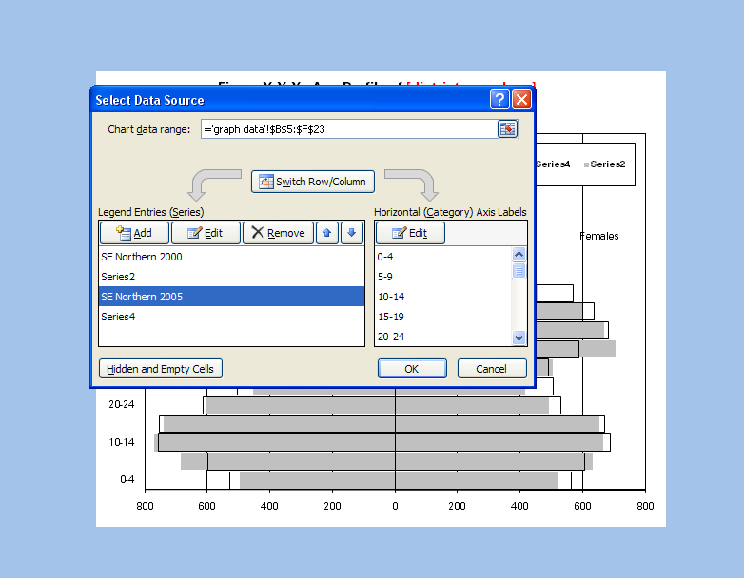

Step 13: repeat steps 11 & 12 for the ‘rha v. mb’ graph, BUT only change the first series name –
Manitoba (the third series) is correct for this graph (it is the comparison group here)

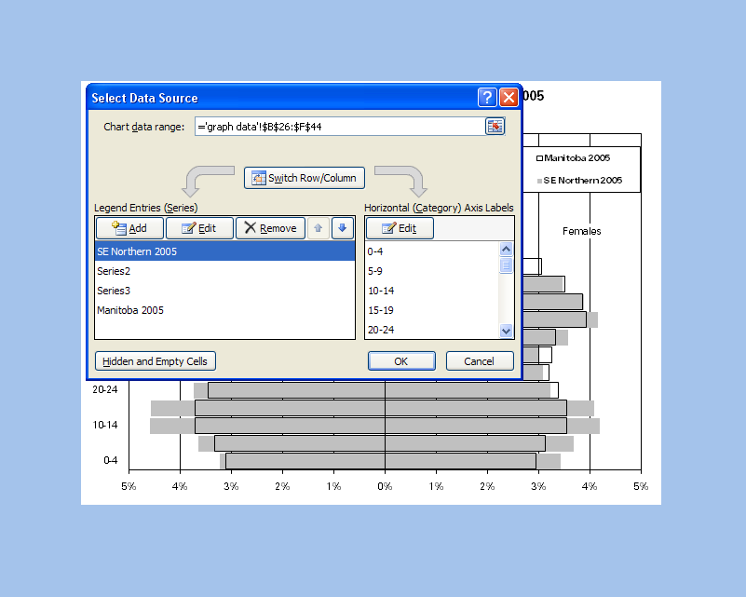

Step 14: change the graph scales (if necessary) by double left clicking on the horizontal graph
axis, selecting ‘scale’ tab and changing values in ‘minimum’ and ‘maximum’ boxes



